How to Tie a Karate Belt
Need to know how to tie a karate belt or obi? Here is a method with Step-by-step diagrams that will help and eliminate the cross-over on the backside of the belt. This method is native to Okinawa, the home of karate and ends with the 3-position knot.
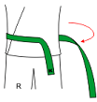 | - Start by holding the label end of the belt across your abdomen, in front of you with your right hand. It should hang a couple of inches longer that the length you want the belt to be once tied. Wrap the other end behind you and around your waist with your left hand.
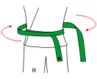 | - Wrap the belt around your waist a second time while maintaining the position of the label end of the belt.
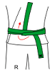 | - Tuck the non-label end of the belt under both layers and up. Pull both ends to tighten the knot
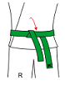 | - Fold down the non-label end of the belt.
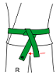 | - Tuck the label end of the belt under the other end and over to your right side.
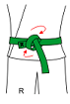 | - Loop the label end of the belt around the other end and through the knot.
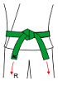 | - Pull to tighten the knot. If the belt ends are not the same length, unite the knot and adjust the length to suit.

