Eighth Kyu – Yellow belt
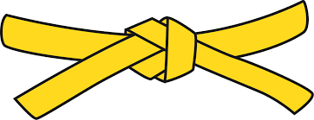
BASICS
KIHON WAZA - Basic techniques
- Jodan Uke - Upper block
- Chudan Soto Uke - Middle outer block
- Chudan Uchi Uke - Middle inner block
- Gedan Barai - Lower sweeping block
- Junzuki - Lunge punch
- Gyakuzuki - Reverse punch
- Maegeri - Front kick
- Uraken Jodan - Back fist head
RENKEI WAZA - Combination techniques
- Maegeri Chudan, Tobikomizuki Jodan - Front kick middle, Snap punch head
- Maegeri Chudan, Gyakuzuki Chudan - Front kick middle, Reverse punch middle

PAIR WORK
IPPON KUMITE - One step blocks
- Jodan Uke Ipponme - Head block One
- Chudan Uke Ipponme - Middle block One
- Maegeri Uke Ipponme - Kick block One

