Fifth Kyu – Blue Belt
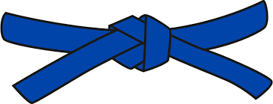
BASICS
KIHON WAZA - Basic techniques
- Kette Junzuki
- Kette Gyakuzuki
- Kette Junzuki No Tsukkomi
- Kette Gyakuzuki No Tsukkomi
- Tobikomizuki
- Nagashizuki
- Ushirogeri Chudan
- Tobigeri
RENKEI WAZA - Combination techniques
- Mawashigeri Chudan, Ushirogeri Chudan, Gyakazuki Chudan
- Tobikomizuki Jodan, Chudan Zuki, Mawashigeri Chudan
PAIR WORK
IPPON KUMITE - One step blocks
- Jodan Uke - Nihonme & Yohonme
- Chudan Uke - Nihonme & Yohonme
- Maegeri Uke - Nihonme & Yohonme
OHYO KUMITE – Semi-free fighting
- Nihonme

KATA
Pinan Shodan & Pinan Yodan

JI YU KUMITE

