Sixth Kyu – Green Belt
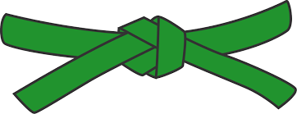
BASICS
KIHON WAZA - Basic techniques
- Kette Junzuki
- Kette Gyakuzuki
- Tobikomizuki
- Shuto Uke
- Surikomi Maegeri Chudan
- Surikomi Mawashigeri Chudan
- Surikomi Sokuto Chudan
- Uraken
RENKEI WAZA - Combination techniques
- Maegeri Chudan, Sokuto Chudan, Gyakazuki Chudan
- Tobikomizuki Jodan, Chudan Zuki, Maegeri Chudan
PAIR WORK
IPPON KUMITE - One step blocks
- Jodan Uke - Ipponme & Sanbonme
- Chudan Uke - Ipponme & Sanbonme
- Maegeri Uke - Ipponme & Sanbonme
OHYO KUMITE – Semi-free fighting
- Ipponme
KATA
Pinan Shodan & Pinan Sandan

JI YU KUMITE

