First Kyu – Senior Brown Belt
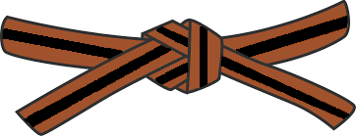
BASICS
KIHON WAZA - Basic techniques
- Kette Junzuki
- Kette Gyakuzuki
- Kette Junzuki No Tsukkomi
- Kette Gyakuzuki No Tsukkomi
- Nagashizuki
- Surikomi Mawashigeri Jodan
- Surikomi Sokuto Jodan
- Ushirogeri Chudan
RENKEI WAZA - Combination techniques
- Zenshinshite Jodan, Chudan Zuki, Maegeri Chudan, Nagashizuki Jodan, Gyakuzuki Chudan, Mawashigeri Jodan
- Sunegeri, Mawashigeri Jodan, Ushirogeri Chudan, Gyakuzuki Chudan
PAIR WORK
IPPON KUMITE - One step blocks
- Jodan Uke - Ipponme & Yonhonme
- Chudan Uke - Ipponme & Yonhonme
- Maegeri Uke - Ipponme & Ropponme
OHYO KUMITE – Semi-free fighting | KIHON KUMITE – Basic fighting
- Ropponme | - Ropponme
- Nanahomne | - Nanahomne

KATA
Naihanchi, Seishan, Chinto, Pinan Shodan

JI YU KUMITE

